**Scaffolding depth cues and perceptual learning in VR to train stereovision: A proof of concept pilot study.**

Angelica Godinez1, Santiago M González2, Dennis M Levi1

1School of Optometry, University of California, Berkeley

2Construcción e Ingeniería de Fabricación, Universidad de Oviedo

Acknowledgements: This research was supported by The UC Berkeley, Chancellor and Regents Graduate Fellowship (AG), NIH training grant T32EY007043-40 (AG), grant R01EY020976 (DML) from the National Eye Institute and received mobility aid from the Universidad de Oviedo (SMG).

**Abstract**

Stereopsis is a valuable feature of human visual perception which may be impaired or absent in amblyopia and/or strabismus but can be improved through perceptual learning (PL). The development of consumer virtual reality (VR) technology may provide a useful new intervention model for improving stereovision. To evaluate the effect of VR treatment in stereopsis, we set out to develop a novel VR PL strategy based on a principled approach which included aligning and balancing the perceptual input to the two eyes, exposure to large disparities, scaffolding different cues to depth and perception for action. To evaluate this approach we recruited twenty adults (mean age: 28 ± 2.5, range: 18 – 62 years, 14 female) with normal vision (stereo-normal group, n=10) and binocular impairment (stereo-anomalous group, n=10, five with strabismus, four with anisometropia, and one stereo-weak). In order to improve stereopsis, participants played two novel PL games (DartBoard and Halloween) using a VR head mounted display (VR-HMD).  Each game consisted of three depth cue scaffolding levels: the first included both non binocular (shadows, perspective and motion parallax) and binocular (disparity) cues to depth; the second level eliminated shadows and perspective and the third level had only binocular disparity available. Most of the stereo deficient players (X/N) improved in the game and showed transfer to both clinical and psychophysical tests (means stereoacuity changed from a value of xxxxxxx before dichoptic training to a value of yyyyy of arc after training, p < 0.05). The stereo-normal participants also showed in-game improvement, which transferred to psychophysical tests (means from a value of xxxxxxxxx to a value of yyyyyy p <0.05. We conclude that a VR PL approach based on depth cue scaffolding may provide a useful new method for improving stereoacuity in both stereo-anomalous and stereo-normal subjects.

**Introduction**

Our rich perception of depth provides important information for navigation (Bonnen et al. VSS 2109) and action (Melmoth et al., 2009; Melmoth & Grant, 2006) . Depth perception is a complex process which requires the brain to integrate many different visual cues (Wade & Swanston, 2013). Of those cues, many require only one eye (non-binocular cues) and include overlapping (interposition), perspective (conical projection), lighting-shading, chromatic attenuation, focus and motion parallax (created by the relative motion between an observer’s head and the perceived scene.)

On the other hand, binocular cues such as convergence and retinal disparity, require both eyes (binocular cues). Retinal disparity or stereopsis arises from binocular parallax: each eye is exposed to a slightly different image of the world that the brain must integrate into a single cyclopean percept (Wheatstone, 1838). Given the variety of visual cues to integrate, humans adopt a statistically optimal strategy for combining visual cues to depth (Hillis et al., 2004; Knill & Saunders, 2003). This strategy is also present when integrating visual cues to depth with other modalities, namely touch (Ernst & Banks, 2002; van Beers et al., 2011). When sensory noise and cue conflict are relatively low, the optimal model, aimed at reducing variance (Ernst & Banks, 2002; Hillis et al., 2004; Knill & Saunders, 2003), is a linear weighted average of all cues. However, optimal integration seems to be adaptable and can be influenced through feedback (Atkins et al., 2001; Ernst et al., 2000; Jacobs & Fine, 1999), though feedback is not required (Knill, 2007a). This reweighting of context-specific priors seems to be highly adaptable (Jacobs & Fine, 1999; Knill, 2007a, 2007b) and can occur at a relatively fast rate (van Beers et al., 2011). Importantly, by pairing haptic feedback with binocular cues, observers can be trained to upweight binocular disparity cues (Ernst et al., 2000; Knill, 2007b; Vedamurthy et al., 2016). Optimal cue integration and the adaptability of cue reweighing suggests that observers who lack stereovision, can indeed be trained to rely on binocular cues.

Stereopsis plays a key role in extracting depth information from natural scenes (Mckee & Taylor, 2010), breaking camouflage (Adams et al., 2019), and planning and executing everyday visuomotor tasks (Melmoth et al., 2009; Melmoth & Grant, 2006) (add Bonnen). However, abnormal visual experience during a “sensitive period” of development (Banks et al., 1975; Held et al., 1980) may result in amblyopia and, as a result, in reduced or absent stereopsis (Webber & Wood, 2005). Amblyopia, the leading cause of visual loss in children, is a neuro-developmental disorder that arises from an imbalance between the ocular inputs to the visual pathway (Hess et al., 2010; Li et al., 2007; Ding, Klein & Levi, 2013). It is characterized as reduced visual acuity in an otherwise normal eye despite best optical correction (Holmes & Clarke, 2006) and is typically secondary to misalignment of the visual axis (strabismus) and/or unequal refractive error (anisometropia).

Under everyday conditions, the loss of stereopsis is the most significant issue for individuals with amblyopia and strabismus, affecting their ability to reach and grasp (refs), to navigate safely and rapidly (Bonnen) and to play certain sports (cite). Indeed, a recent analysis suggests that ≈ 7% of the population may be stereoblind (Chopin et al, 2019). Thus, for the overall well-being of people with amblyopia, stereopsis may be an important function to recover and/or strengthen. Perceptual Learning (PL), defined as “any relatively permanent and consistent change in the perception of a stimulus array following practice or experience with this array (…)” (Gibson, 1963), has demonstrated great potential in amblyopia treatment (Levi & Li, 2009). Although functionally suppressed when viewing binocularly (Birch, 2013; Tavers, 1938), binocular mechanisms seem to be intact in some people with amblyopia (Ding & Levi, 2014; Giaschi et al., 2013; Hess et al., 2014), making stereo training a viable option. A number of different approaches have been evaluated for the recovery of stereoacuity when compromised by amblyopia (see Levi et al., 2015 for a review). Interestingly, individuals with strabismic amblyopia have a higher probability of improvement with dichoptic training compared to monocular training and fare even better with direct training (Levi et al., 2015). Furthermore, people with normal binocular vision can also benefit from training, improving their stereoacuity thresholds (Schoemann et al., 2017). However, laboratory-based paradigms require participants to sit through many hours of monotonous psychophysical training (Ding & Levi, 2011).

Considering that the main drawbacks of most laboratory-based training paradigms are participant compliance, attention and motivation, several authors have proposed the use of specifically designed video games to treat amblyopia. Gamification, i.e. the use of game principles in non-game contexts, include the use of levels of increasing difficulty adapted to participant performance, rewards, a story line, and social context, among other aspects (Bergeron, 2005; Kapp, 2012; Michael & Chen, 2005). Several laboratory studies have reported benefits of using video games to treat amblyopia (Li et al., 2015; Li et al., 2009; Li et al., 2011; Vedamurthy, Nahum, Bavelier, et al., 2015; Vedamurthy, Nahum, Huang, et al., 2015) (add Thompson & Hess, 2015), and direct stimulation of stereopsis has been tested using this approach (Portela-Camino et al., 2018). However, we note that several clinical trials aimed at improving visual acuity (Gao et al., 2018; Holmes et al., 2016; Kelly et al., 2016; Manh et al., 2018), have had mixed results.

Recent commercialization of VR-HMDs have opened the opportunity to design therapies that incorporate gamification principles and build upon successful laboratory-based techniques such as PL and dichoptic training. VR-HMDs provide researchers and clinicians with the ability to present separate images to each eye, correct through software any misalignment due to strabismus without the need of a chin rest, and adjust contrast or luminance independently for each eye until balanced binocular vision is achieved. VR-HMDs provide a wide visual field, facilitating vergence in users with strabismus, and large disparities that may help in amblyopia treatment. Furthermore, VR-HMDs provide the ability for researchers to control depth cue content, with the exception of accommodation, which is the only cue without a commercial solution (Love et al., 2009).

Our aim for this study was to develop and pilot test two VR games that combine demanding stereovision tasks, dichoptic PL and depth cue scaffolding. The games were designed to incorporate seven principles: 1) alignment of images on corresponding points, and 2) balancing the perceptual input to the two eyes in order to facilitate fusion; 3) combining non-binocular and binocular cues to depth as a ‘scaffold’ for depth judgements and systematically reducing the non-binocular cues; 4) exposure to large binocular disparities. Recent work has shown that viewing engaging, immersive 3D action videogames with large disparities improved stereoscopic vision in both amblyopic (Li et al., 2019) and neurotypical observers (Levi & Li, VSS 2019; 5) requiring depth perception for action; 6) rich feedback, and 7) the ability to track in-game performance.

**Methods**

**Participants**

Twenty adults (mean age: 28 ± 2.5, range: 18 – 62 years, 14 female) participated in the study, 10 with normal or corrected-to-normal vision and without ocular pathologies (stereo-normal group) and 10 with binocular impairment (stereo-anomalous group). Participants were recruited by telephone from the Meredith W. Morgan University Eye Center’s internal list of patients who gave written consent to be contacted for research studies and through internal UC Berkeley student list serves. The study protocol was approved by the Institutional Review Board of the University of California, Berkeley. Exclusion criteria for the study included: (1) ocular pathologies (e.g., macular abnormalities) or nystagmus, (2) non-concomitant or large angle constant strabismus (> 30 prism diopter), (3) inability to fuse, (4) constant esotropia (> 20 prism diopters), (5) visual acuity (VA) ≥ 20/200, and (6) previous dichoptic visual training of more than 10 hours.

**Study design and training**

All participants underwent a complete clinical assessment before and after the study (Figure 1). The complete clinical assessment included evaluation of: (1) retinal health (ophthalmoscopy), (2) current prescription, (3) refraction at distance, (4) VA (Bailey Lovey visual acuity chart), (5) ocular deviation (monocular cover-uncover test and alternate cover test, using accommodative stimuli, and 4BO test), (6) binocular fusion (Worth Dot at 33 cm and 3 meters), and (7) clinical stereoacuity (Randot Circles Stereotest® and Random Dot 3 Stereo Acuity Test with Lea Symbols®).

Participants were categorized as having anisometropia if there was a difference ≥ 0.50 D in spherical equivalent refraction or ≥ 1.5 D difference in astigmatism in any meridian, between the two eyes (Wallace et al., 2011). Participants were classified as having strabismus in the presence of a tropia with the cover test and/or showing micro-strabismus by the 4∆BO test.

Following the clinical assessment, eligible participants were placed in either the stereo-normal or stereo-anomalous group based on their initial Randot Circles Stereotest® stereoacuity measurement. Inclusion criteria for the stereo-anomalous group were: baseline stereoacuity of 50 arc secs or worse. According to this criterion, ten participants were assigned to the stereo-anomalous group and ten to the stereo-normal group. Four participants in the stereo-anomalous group had anisometropia and five strabismus (one of them micro-strabismus). The remaining participant in the stereo-anomalous group did not exhibit anisometropia or strabismus and was labeled stereo-weak (Supplemental Table 1).

Figure 1. Study and training schematic. Each participant began with a clinical assessment. Followed by clinical and psychophysical stereoacuity tests. Participants then alternated between playing one of two games (Halloween or DartBoard) for 10 hours. After a 10-hour block, clinical and psychophysical stereoacuity tests where administered until 40 hours were completed. Lastly, the clinical assessment was administered.

Training was organized in four blocks, each made up of ten 1-hour sessions. Each session was divided into two 30-minute intervals to allow participants to take a break between intervals. In each 10-hour block, participants played one of the two games designed specifically for this study: Halloween or DartBoard. Most participants completed 40 hours of training (4 blocks) with the exception of N2 and N4 who completed 20 hours, and AS1, AA1, N5, N7, N9, N10 who completed 50 hours total (in these cases, DartBoard was played 30 hours).

To monitor participant progress, participants completed both clinical and psychophysical stereoacuity tests after each 10-hour training block. For clinical stereoacuity, we used the random-dot stereogram Randot Circles Stereotest® (RCS) and Random Dot 3 Stereo Acuity Test with Lea Symbols® (RD3). For psychophysical tests, we used the Pure Disparity Test (PDT) and a dynamic random-dot stereogram test (DRS)described in detail in Ding & Levi, 2011. Briefly, stimuli were viewed through a stereoscope and presented on a Sony CRT monitor (CPD-G500) at a viewing distance of 68 cm from the participant. DRS stimuli consisted of circular bright dots (126 cd/m2) on a dark background (1.37 cd/m2) and were presented in three different sizes (small: 22.64, medium: 90.55, big: 362 arc secs). PDT stimuli consisted of two 3° x 3°sine-wave gratings (0.67 cpd) at 48% contrast with sharp edges. Once the training was considered finished, the clinical assessment was administered again.

**Games and apparatus**

The games were presented on the Oculus Rift® Developer Kit (DK) 2, which is equipped with a gyroscope, accelerometer, and a magnetometer with an update rate of 1000 Hz. The Oculus Rift DK-2 has a resolution of 960 x 1080 for each eye, a field of view of 100 degrees, a refresh rate of 60-75 Hz, and a position tracking refresh rate of 60 Hz. To run the software, we used the Alienware AREA51R2 computer with Intel® Core™ i7-5820K CPU and an NVIDIA GeForce GTX 980 graphics card.

Importantly, for participants who were unable to fuse the images due to strabismus and/or suppression, games started with a high contrast fusion-lock frame presented to each eye, and a dichoptic nonius calibration. To correct for misalignment, the researcher manually adjusted the images presented to each eye (horizontal, vertical, and cyclo deviations, plus aniseikonia) until the participant reported complete alignment of the dichoptic cross (Figure 2- Top left), allowing correction for any deviation in the subjective angle of squint. To minimize or eliminate suppression, image luminance (ranging from equal luminance of both images to complete occlusion of one eye) was adjusted for the dominant eye until the participant reported equal luminance of the dichoptic lines crossing at the reference frame.

Briefly, Dartboard game required participants to judge the movement of a dartboard in depth (z-direction) and release a dart (presented in front, parallel to the participants’ eyesight) to hit the center of the board. After each attempt, they were given an auditory tone to indicate that they hit the board and visual feedback indicating the number of points they received. If the dart hit the center of the board, participants received a trophy which was displayed on the screen. Additionally, a scoreboard to the left of the participant kept track a number of performance variables (e.g., level, points, accuracy (stereoacuity in the video), average accuracy). The Halloween game required participants to judge which target in a series of 3-5 was closest and eliminate them sequentially (see video for reference). Again, participants were presented with both auditory (gunshot sound) and visual (points and written feedback such as “Great!”) to indicate that they hit the target.

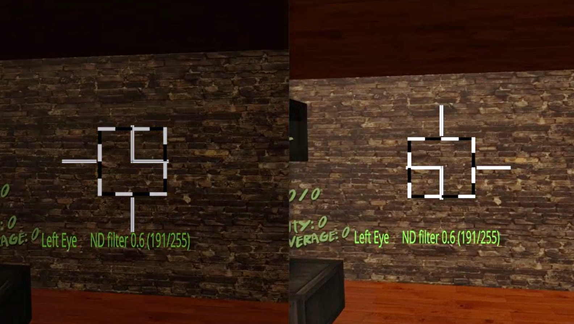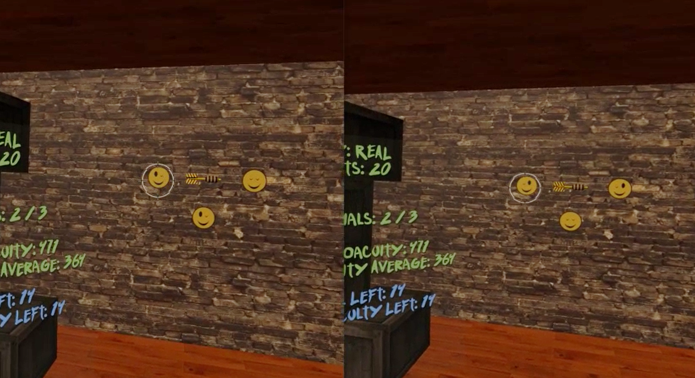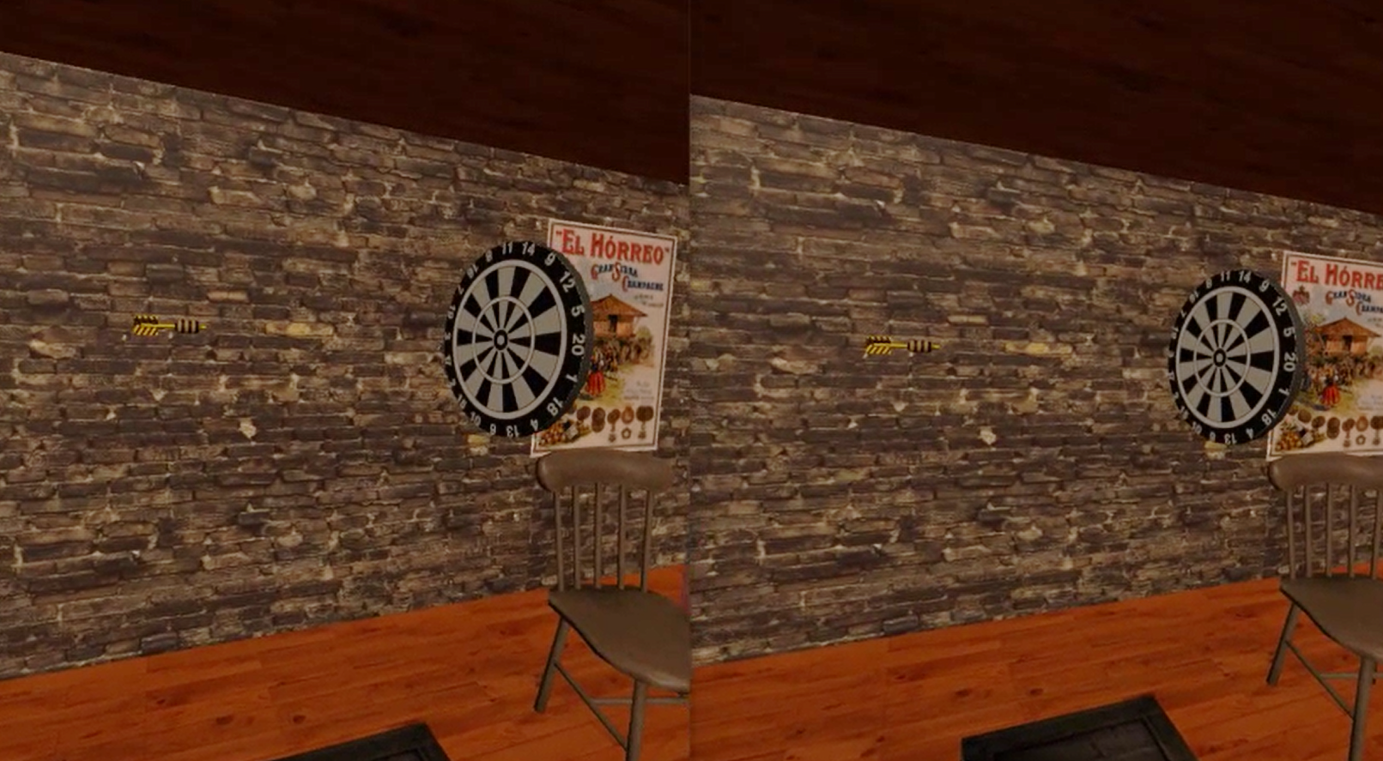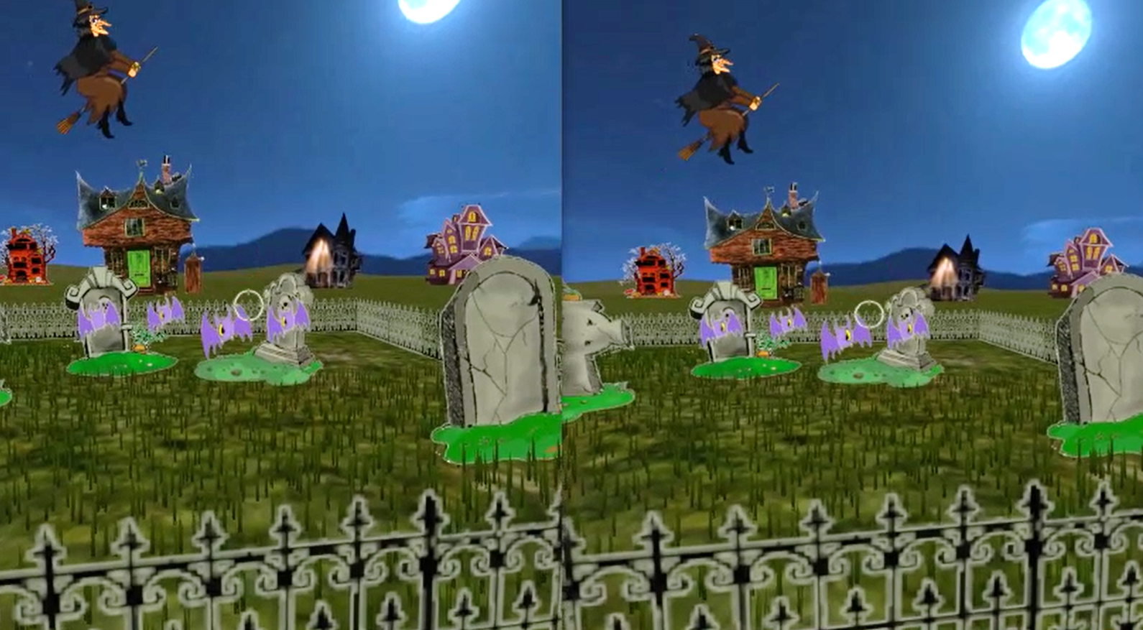

Figure 2. DartBoard and Halloween game screenshots. Top left: Fusion-lock frame calibration for DartBoard (similar in Halloween) to eliminate subjective misalignment angles. Top right: DartBoard 3-AFC suppression task. Bottom left: DartBoard trial example. Bottom right: Halloween trial example.

Cue scaffolding was implemented in both games, creating three consecutive cues scaffolding conditions (Level 1, 2, and 3), which progressively eliminate non-stereoscopic depth cues, from an up-to-date VR scene (where accommodation is the only depth cue not simulated) to a scene where only retinal disparity was available. Each 30-min interval began with Level 1, which consisted of non-binocular and binocular cues to depth including shadows, perspective, motion parallax, and binocular disparity. In Level 2, shadows were eliminated and perspective reduced - meaning, relative size was no longer a reliable cue (i.e., object size was not relative to object distance). Lastly, in Level 3, motion parallax was limited (only rotational movements of the head were allowed by the software), making binocular disparity the most helpful (almost unique) cue to calculate distance.

A suppression task (by means of dichoptic images) was also inserted in each games’ mechanics to help participants become aware of suppression episodes. For example, in the DartBoard game, participants were instructed to identify the smiley face (in a set of three) with both eyes open (3-AFC), which could only be seen if binocular fusion was maintained (Figure 2- Top right). In the Halloween game, participants were instructed to destroy all targets with both eyes open and avoid targets with only one eye, which again could only be achieved if binocular fusion was maintained. Importantly, the purpose of the suppression task was to bring awareness of suppression episodes to participants who actively suppressed. Suppression failures were registered in both game result files.

Game mechanics and respective in-game measurements were different in the two games. In DartBoard, participants were instructed to launch a dart, which was presented at the center of the screen, towards a dartboard that traveled from the back of the participant and moved towards the background of the scene (Figure 2- Bottom left). Each dart launch ended a trial. Movement of the dart once launched, was always linear and traveled from left to right, while movement of the board was linear, but not necessarily at a 90° angle or at the same speed of the dart. Both linear movements occurred in the same plane where the observers’ eyes were. Thus, there was no way of guessing the intersection of both trajectories using purely monocular cues. The motion of the dart board was designed to stop at intervals in order to facilitate the exercise. The perceptual learning task for the participant was to estimate, using the background wall as reference, when the dart (the stationary object) and the dart board (the object moving in depth) were at the same distance (i.e. accuracy could theoretically be as low as zero arc secs). In Halloween, participants were instructed to shoot the closest target in a variable set of targets (from three to seven phantoms, pumpkins or vampires) as they approached the participant (Figure 2- Bottom right). Each shot ended a trial. Similar to the movement of the dartboard, the approaching targets stopped at intervals to facilitate the exercise. Importantly, relative parallax between the targets were constant, and decreased across trials from 1000” to 400” over time, depending on the participants’ performance. Therefore, the perceptual learning task in Halloween was to determine the *relative depth distance* between several objects (n-alternative forced choice task). It is important to note that DartBoard in-game measurements result in accuracy threshold values for each trial at each cue scaffolding condition, while Halloween in-game measurements result in the proportion of correct responses for each stereo demand at each condition.

**Data Analysis**

Differences between stereo-anomalous and stereo-normal groups and/or cue scaffolding conditions were calculated through mean comparisons. Analysis of variance was used to establish differences between variables with more than two levels of comparisons. ANOVA was used for variables with a normal distribution and Kruskal-Wallis when distributions were not normal. Two sample comparison was made using Student’s t-test when data followed a normal distribution and Wilxocon-Mann-Whitney otherwise. Kolmogoro-Simirnov test was used to confirm normal distribution of data. The relationship between variables was made through Pearson’s correlation. The significance level was set to 0.05 for all comparisons. The R-Statistics (v3.6.3) software was used to run the analysis.

**Results**

**Changes in stereoacuity**

Figure 3 compares the pre and post stereoacuity threshold for all participants. Figure 3A shows clinical tests data: RCS (open symbols) and RD3 (filled symbols)while Figure 3B shows the psychophysical test data: PDT (triangle), DRS small (small circle), DRS medium (medium circle) and DRS big (big circle). In both figures, colors indicate binocular condition: anisometropia (blue), strabismus (red), stereo-weak (green), and normal stereo (grey). Data under the unity line indicate an improvement in stereoacuity. Note that several observers were “stereoblind” (i.e., unable to respond to the largest disparity presented: 2010” for the psychophysical tests and 900” for the clinical tests) initially, but were able to perform after training. Their data are plotted at the extreme right of each panel in Figure 3.

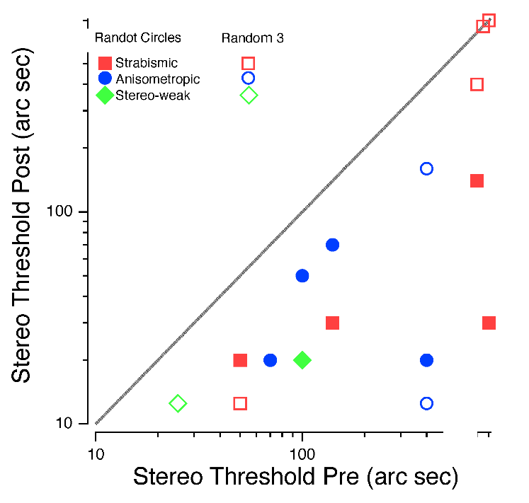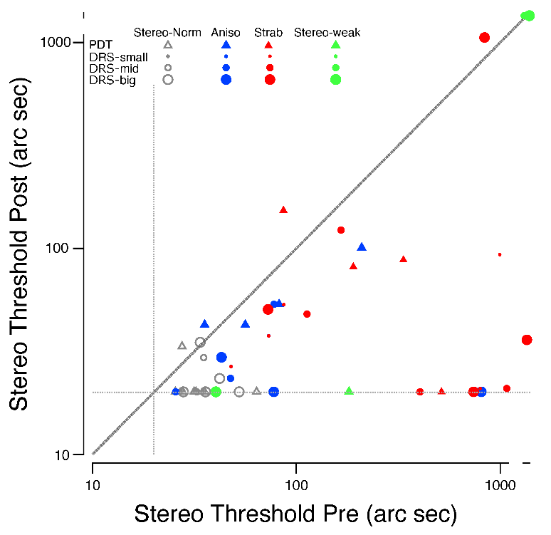

A.

B.

Figure 3. (A) Improvement in clinical stereoacuity as a function of initial RCS (filled symbols) and RD3 (open symbols) threshold. (B) Psychophysical stereoacuity improvement as a function of initial stereo threshold for PDT (triangle), DRS small (small circle), DRS medium (medium circle) and DRS big (big circle). (What does the horizontal line indicate?). In both figures, colors indicate binocular condition: anisometropia (blue), strabismus (red), stereo-weak (green), and normal stereo (grey). Data under the unity line indicate an improvement in stereoacuity.

We first analyzed the mean differences (before and after treatment) for each test between stereo-normal and stereo-anomalous groups (Table 1). We found statistically significant differences between the groups for all four tests, except for DRS small pre- treatment (*p* = 0.05) and DRS big post- treatment (*p* = 0.10).

Table 1

*Pre and post median stereoacuity thresholds for each group and stereoacuity test and statistical mean comparison (p-value).*

|  |  |  |  |  |  |  |
| --- | --- | --- | --- | --- | --- | --- |
|  | Pre – median | | | Post – median | | |
|  | Normal | Anomalous | p-value | Normal | Anomalous | p-value |
| RCS | 20.0” | 100.0” | < 0.01 | 20.0” | 30.0” | 0.01 |
| RD3 | 12.5” | 400.0” | < 0.01 | 12.5” | 89.4” | < 0.01 |
| PDT | 29.5” | 185.6” | < 0.01 | 20.1” | 66.0” | < 0.01 |
| DRS small | 20.1” | 59.1” | 0.05 | 20.1” | 23.6” | 0.01 |
| DRS medium | 20.1” | 93.6” | < 0.01 | 20.1” | 22.1” | 0.04 |
| DRS big | 23.7” | 239.6” | < 0.01 | 20.1” | 24.4” | 0.10 |

The clinical tests show a clear improvement in stereoacuity for stereo-anomalous participants, but that improvement is not evident in the stereo-normal group (Figure 3A) because the stereo-normal participants were all at ceiling. The improvement for stereo-anomalous participants is confirmed by the psychophysical tests, and importantly, these tests which have neither monocular nor non-stereoscopic binocular cues, also reveal significant improvements for the stereo-normal participants (Figure 3B and Table 1).

Adopting the criteria for stereoacuity improvement as an improvement of at least two levels on the clinical tests and a final stereoacuity threshold of 140 arc secs or better (Levi et al., 2015), all participants in the stereo-anomalous group except for ASM1 improved in the RCS test, and all but ASM1, AS1, AS2 and AS4 improved in RD3.

In the stereo-anomalous group, participant AMS1, with micro strabismus, failed to improve according to both clinical tests, although PDT and DRS small show an improvement. Participant AS1, with strabismus, failed to improve according to the RD3, but improved on all the other tests. Participant AS2, also in the strabismic group, did not exhibit improvement with either the RD3 or the PDT (even a small regression), but showed improvements with all the other tests. Finally, participant AA3 (anisometropic) appeared to regress in the PDT test, but he improved according to all the other tests.

Seven of the ten participants in the stereo-normal group showed improvements in the PDT test: N9 and N10 exhibited a regression and N1 was at ceiling. The DRS test also showed improvement in seven of the ten participants: N3 and N5 were at ceiling and N2 exhibited a slight regression in the DRS big. Those improvements were not evident in the clinical tests because all stereo-normal participants were at ceiling before the treatment.

We also analyzed whether the initial (baseline) stereoacuity predicted the magnitude of the improvement in stereoacuity following training (Table 2). Our analysis revealed strong significant correlations between the initial psychophysical stereoacuity threshold and the amount of improvement (i.e., the Pre:Post stereoacuity ratio [PPR]) for the stereo-normal group. The clinical stereoacuity tests failed in this analysis for the stereo-normal group, as the participants were at ceiling. For the stereo-anomalous group the correlations are moderate and not statistically significant (RDS even exhibits an inverse correlation.

Table 2

*Correlation coefficients and p-values using Pearson’s test between PPR and initial stereoacuity values for stereo-normal and stereo-anomalous groups.*

|  |  |  |  |  |
| --- | --- | --- | --- | --- |
|  | Stereo-normal | | Stere-anomalous | |
|  | Correlation | p-value | Correlation | p-value |
| Randot Circles | - | - | 0.49 | 0.16 |
| Random Dot 3 | - | - | -0.18 | 0.63 |
| PDT | 0.92 | < 0.01 | 0.63 | 0.05 |
| DRS small | 1.00 | <0.01 | 0.57 | 0.08 |
| DRS medium | 0.82 | < 0.01 | 0.47 | 0.17 |
| DRS big | 0.88 | < 0.01 | 0.49 | 0.15 |

**Changes in visual acuity**

No significant change in VA were observed after training. This is not surprising since only two of the stereo anomalous observers were amblyopic. The mean change in VA (logMAR) across all participants (n = 20) was 0.004 ± 0.07 [sd] logMAR after training, equivalent to almost no change in visual acuity. The stereo-normal group (n = 10) had a mean visual acuity change of 0.008 ± 0.07 [sd] logMAR while the stereo-anomalous group (n = 10) had a mean visual acuity change of 0 ± 0.06 [sd] logMAR after training. Indicating that there were no significant changes in VA after training.

Participants with anisometropia (n = 4) had a VA change of 0.03 ± 0.08 [sd] logMAR compared to -0.03 ± 0.05 [sd] logMAR for participants with strabismus (n = 5), and 0.04 logMAR for the participant classified as stereo-weak. Of the participants who were classified as having amblyopia (n = 2; AA4 and AMS1), AA4 improved his amblyopic eye by 0.02 logMAR, while AMS1 digressed by 0.04 logMAR.

**Preliminary Control Study**

Prior to the study, to ensure that Level 3 of our games required stereopsis for optimal performance, we asked a neurotypical volunteer to play the game under both binocular and monocular conditions (by means of a patch). For both games, performance was substantially worse (by a factor of ≈ 2) and dichoptic errors substantially increased under monocular conditions (See Supplemental material Tables 1 and 2 for Dartboard and Halloween respectively). This suggests that the Level 3 tasks require stereopsis for optimal performance and cannot be solved using other cues.

**DartBoard in-game performance accuracy**

The DartBoard game provided 102,252 data points corresponding to the activity of the 20 participants. This resulted in approximately 80 trials per condition and hour of game play. Examples of the results collected from four participants are shown in Figure 4 (See Supplemental material Figure 1 for all participants). Each point represents in-game accuracy (in arc sec) after one hour of game play. Each cue scaffolding condition (game Levels 1, 2 and 3) is represented by a different symbol. The solid line represents the fit from an exponential curve, which will be explained below.

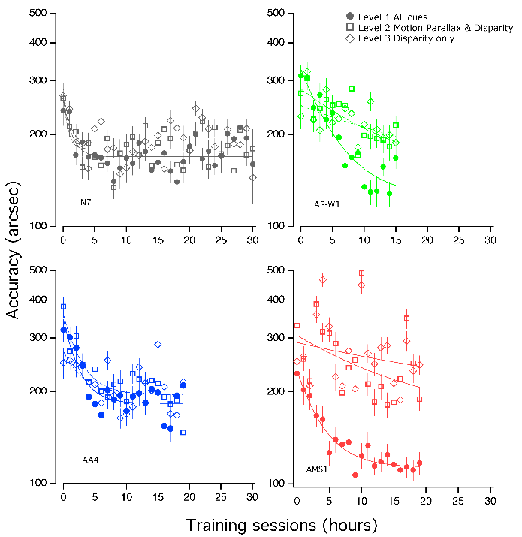

Figure 4. Examples of DartBoard in-game performance accuracy for four participants. Top-left: Stereo-normal participant N7; Top-right: Stereo-weak participant AS-W1; Bottom-left: Anisometropic participant AA4; and bottom-right: Strabismic participant AMS1. Level 1 is represented as solid circles, Level 2 as hollow squares and Level 3 as hollow diamonds.

The Individual data were fit with an exponential curve (Equation 1). From the fit, we calculated the asymptotic final threshold, time constant, and the ratio of baseline (Pre) to asymptotic threshold (PPR) for each participant. The asymptotic final threshold represents the best performance achieved through training. The time constant represents the rate of learning and is determined by the time it took for the exponential to fall 37% (1/e) of the initial value. Lastly, the PPR represents the amount of learning as a factor of the initial performance with a higher PPR indicating greater learning.

Equation 1. $\left(PPR×e^{-\frac{\# of sessions}{Time constant}}+1\right)×asymptotic threshold$

Mean values and confidence intervals for each parameter per condition and group are shown in Figure 5. The results for participants N5, N10 and AS2 are not included, as the time constant parameter in the exponential fits were outliers. According to these results, the asymptotic performance appears to be higher (worse) for the stereo-anomalous group and Level 3. The PPR seems to be more dependent on level in the stereo-anomalous group, decreasing with level. Finally, the time constant seems to be more dependent on level for stereo-anomalous group, reaching longer values in Level 3.

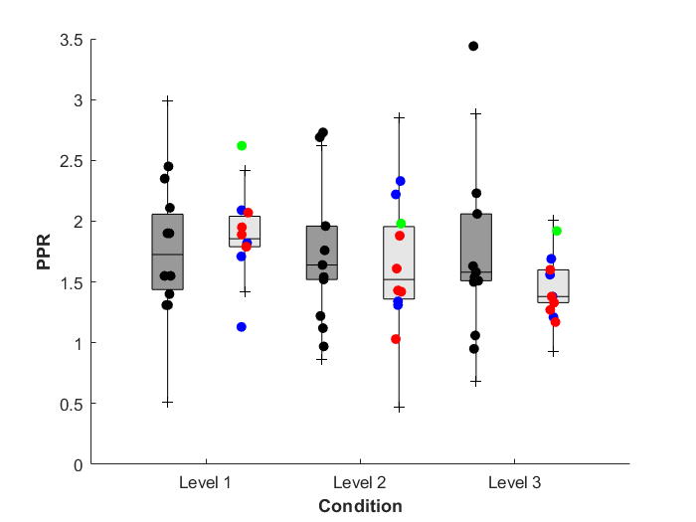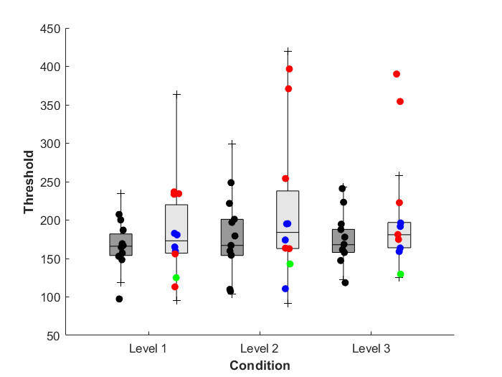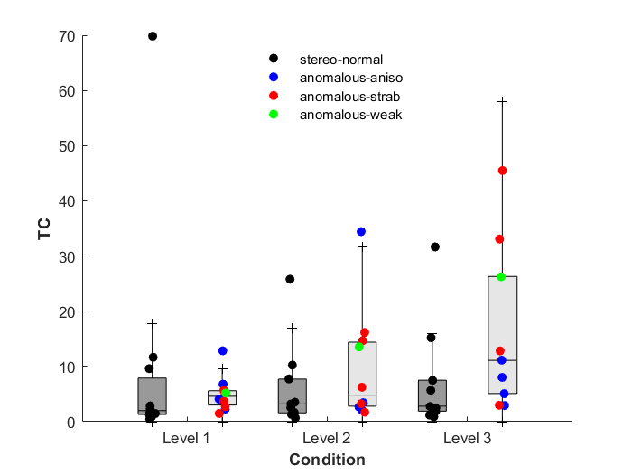

Figure 5. Box plots of DartBoard in-game performance accuracy, from the exponential fits: PPR, asymptotic threshold and time constant. Medians and interquartile ranges for each group and condition considered. Threshold values in seconds of arc.

**Statistical Analyses**

To quantify these results we performed statistical analyses (see Methods). The PPR results show that all participants in the stereo-anomalous group improved in all cue scaffolding conditions, as most stereo-normal participants did. Only N3 in condition Level 3 (PPR = 0 0.95) and N5 in condition level 2 (PPR = 0.97) fail. PPR analysis using Kruskal-Wallis test show that there are not statistically significant differences due to condition for stereo-normal group (*p* = 0.81), meaning that stereo-normal participants behave similar in the three conditions. Meanwhile, stereo-anomalous group shows statistically significant differences due to condition (*p* = 0.04), that are also (and only) significant when we compare cue scaffolding conditions 1 and 3 (*p* = 0.01), meaning that stereo-anomalous participants behaves different in both conditions. Mann-Whiney test doesn’t show any statistically significant difference between groups in any of the three conditions, meaning that in any of tree cue scaffolding conditions the behavior of both groups is similar.

The other two parameters obtained in the exponential fit (final threshold and time constant) fail to show any statistically significant difference.

We found statistically significant correlations (Pearson) between the PPR and initial threshold (instead of final) as obtained from the exponential fits (Table 3) for stereo-normal participants in all conditions, that is for Levels 1 and 3. In contrast, stereo-anomalous participants show an inverse or null correlation in Level 2 and 3, and the correlations are not significant in any condition.

Table 3

*Pearson’s correlation and p-values for PPR and initial stereoacuity threshold for each group and cue scaffolding condition.*

|  |  |  |  |  |
| --- | --- | --- | --- | --- |
|  | Stereo-normal | | Stereo-anomalous | |
| Condition | Correlation | p-value | Correlation | p-value |
| Level 1 | 0.56 | 0.09 | 0.38 | 0.28 |
| Level 2 | 0.53 | 0.15 | -0.07 | 0.85 |
| Level 3 | 0.77 | 0.02* | -0.36 | 0.35 |

The Kolmogorov-Smirnov test showed that the DartBoard game data did not follow a normal distribution when analyzed as a whole, or considering the six subgroups obtained from participant group (stereo-anomalous and stereo-normal) and cue scaffolding conditions (Level 1, 2 and 3) (*p* < 0.01 in all cases). Therefore, non-parametric tests were used for the following analysis.

Median and interquartile range (calculated using Bootstrap method) are shown for each group and condition in Table 4.

Table 4.

*DartBoard in-game performance accuracy. Median and interquartile range for each group and condition.*

|  |  |  |
| --- | --- | --- |
| Condition | Stereo-normal (arc secs) | Stereo-anomalous (arc secs) |
| Level 1 | 186 [113 – 297] | 206 [119 – 337] |
| Level 2 | 195 [114 – 313] | 241 [136 – 404] |
| Level 3 | 193 [115 - 310] | 240 [136 – 410] |

The Kruskal-Wallis test shows that performance accuracy is different in the stereo-normal group from that of the stereo-anomalous group (*p* < 0.01 for both groups). Mann-Whitney mean comparisons between each pair of cue scaffolding conditions (levels) show that data from Level 1 and Level 2 are different for both groups (*p* < 0.01 in both), as are Level 1 and Level 3 (*p* < 0.01 in both). When comparing Level 2 and Level 3, mean values are different for the stereo-anomalous group (*p* = 0.01) but not for stereo-normal group (*p* = 0.53). The mean comparison between groups, stereo-normal and stereo-anomalous, at each cue scaffolding condition (Level 1, 2 or 3), using Mann-Whitney test, shows that results are different for both groups at each condition (*p* < 0.01 in the three conditions).

We also evaluated whether there is a correlation between the DartBoard performance accuracy and the clinical and psychophysical tests (Table 5). We were interested mainly in condition 3, where only retinal disparity is available. For this analysis, we compared pre- and post- thresholds obtained by each participant in DartBoard using the PPR derived from the exponential fits. We consider only stereo-anomalous participants, as stereo-normal were all at ceiling. We found medium to high correlations in all cases. The correlation values obtained with Randot Circles were larger than the correlation found between Randot Circles and any of the other tests.

Table 5

*Pearson’s correlation coefficients and p-values for DartBoard in-game performance accuracy in Level 3 and PPR for the clinical tests (RCS and RD3) and psychophysical tests (PDT, DRS small, DRS medium, DRS big).*

|  |  |  |  |  |  |  |
| --- | --- | --- | --- | --- | --- | --- |
|  | Randot Circles | Random Dot 3 | PDT | DRS small | DRS medium | DRS big |
| Correlation | 0.70 | 0.73 | 0.52 | 0.44 | 0.34 | 0.54 |
| p-value | <0.01 | <0.01 | 0.02 | 0.05 | 0.14 | 0.01 |

Finally, we were interested in comparing the improvements in cue scaffolding conditions 1, where all depth cues are available, vs condition 3, where only retinal disparity is available. Additionally, those improvements may depend on the initial performance accuracy. A participant who exhibits good in-game accuracy when all depth cues are available (Level 1) but performs poorly when only retinal disparity is present (Level 3), is perhaps likely to improve more in Level 3 than in Level 1 after treatment (i.e. the lower the initial threshold ratio between Level 1 and Level 3, the lower the PPR ratio between Level 1 and 3). In Figure 6 each participant is represented as an arrow, whose start point is the initial accuracy level, for Level 1 on the abscissa and Level 3 on the ordinate. The horizontal arrow length is proportional to the improvement in the use of all depth cues when available (PPR for Level 1); the vertical arrow length is the improvement in the use of retinal disparity alone (PPR for Level 3). All arrows point towards a game accuracy limit that is located in the lower left corner of the graph. If performance improves by the same amount for the two levels, the arrows would be oriented at 45 degrees (parallel to the unity line). Orientations less than 45 degrees indicate greater improvement with all cues (Level 1); orientations greater than 45 degrees show more improvement with disparity only (Level 3). The stereo-anomalous participants are all represented by arrows at angles less than 45 degrees, i.e. the improvement attributable to the use of retinal disparity was less than the improvement attributable to the use of all depth cues combined, i.e., for conditions more similar to those occurring in natural viewing.

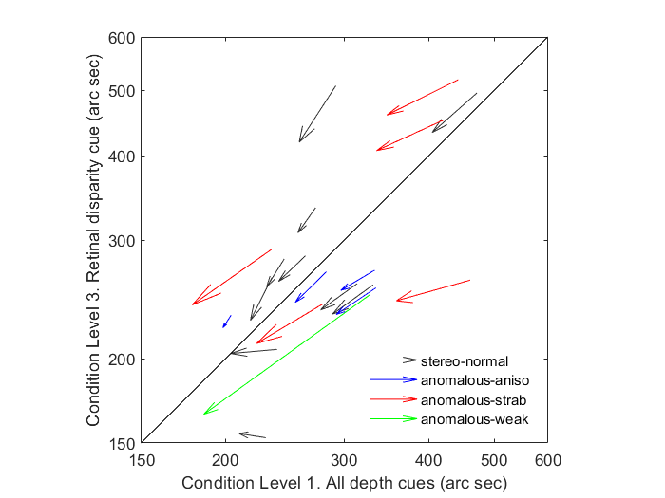

Figure 6. DartBoard in-game performance accuracy initial thresholds and PPR in two cue scaffolding conditions (Level 1 vs Level 3). Each participant is represented as an arrow. The start point of the arrow is the initial accuracy (in arc secs); horizontal arrow length shows the improvement in game accuracy (Level 1), and vertical length is the improvement in game accuracy (Level 3). The arrows are elongated to facilitate identification of arrow direction, i.e. end point does not represent the performance. Arrows with start points below the diagonal unity line show better initial performance when all depth cues are present compared with the performance when only retinal disparity is available. Arrows with angles lower than 45 degrees show greater improvement with all cues than for stereoacuity alone. Stereo-normal participants are represented in black, stereo-anomalous are represented in different colors depending on subclassification: anisometropic in blue, strabismic in red, stereo-weak in green.

Interestingly, the PPR ratio between Levels 1 and 3 correlates (Pearson’s test) strongly with initial performance ratio in both the stereo-normal (r = 0.72) and stereo-anomalous groups (r = 0.54), but the correlation is statistically significant in stereo-normal group (*p* = 0.02) and not in stereo-anomalous (*p* = 0.10).

**Halloween in-game performance**

As noted previously, our in-game performance measures for Halloween are the proportion of correct responses (hits) for each stereoscopic demand (1000, 800, 600, and 400 arc secs) for each cue scaffolding level for each session. To assess improvements, we performed an m-alternative signal detection (d’) analysis (MacMillan & Creelman, 2005), since the number of choices varied across trials (from 2 – 7?). This analysis takes into account the number of available choices (targets) at each stereo demand (Hacker & Ratcliff, 1979; Bi, Lee & O’Mahony, 2010). Specifically, we computed d’ for the first three hours of game play (pre) and the last three hours to get a pre/post assessment. Figure 7 shows d’ pre (abscissa) vs d’ post (ordinate) for the largest and smallest disparity levels (i.e., 1000” and 400”). Values above the unity line indicate an improvement in d’ following training. Interestingly most of the points lie above the unity line, for all 3 conditions and for both disparities.

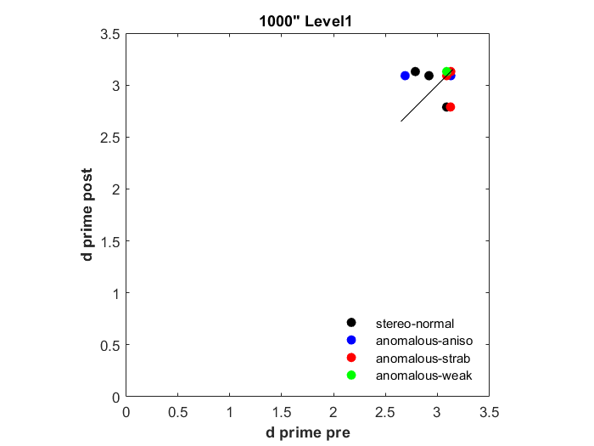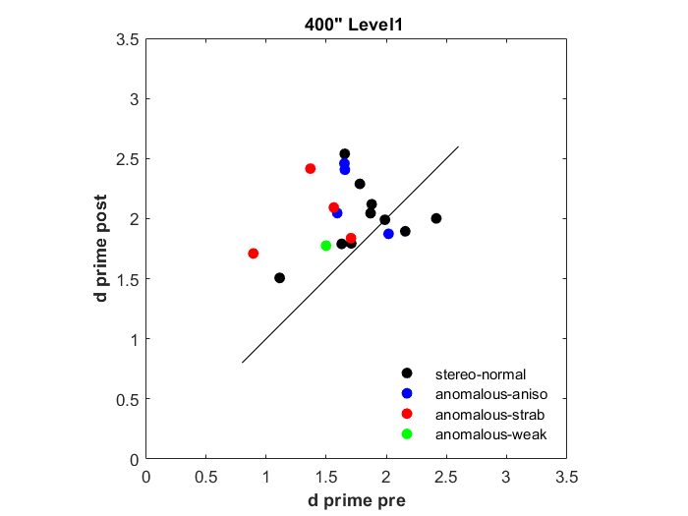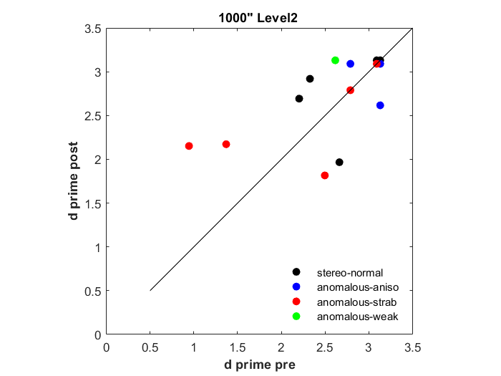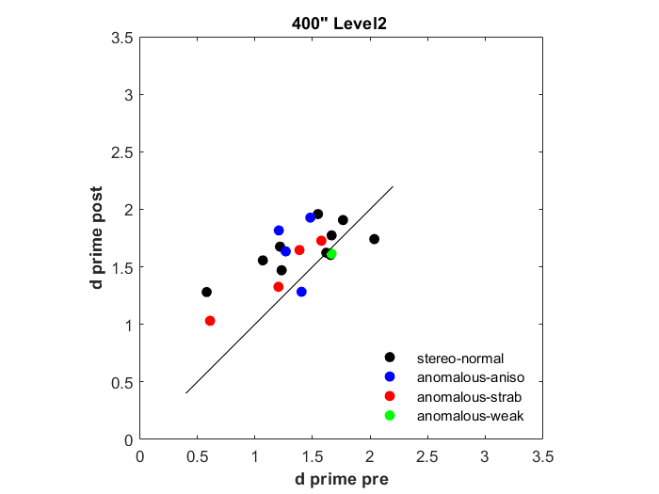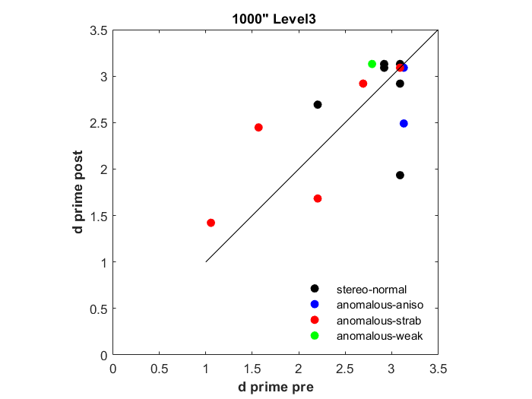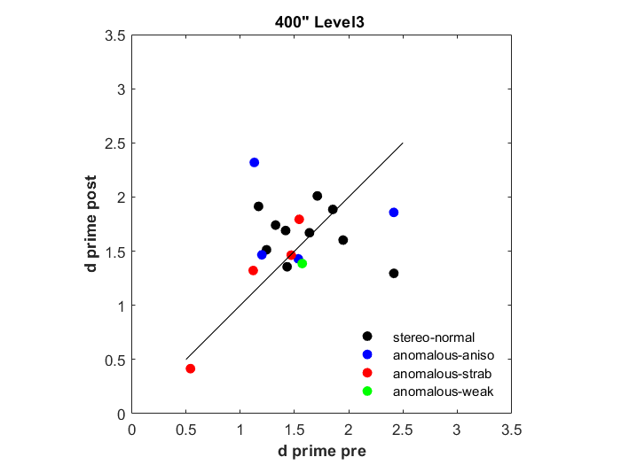

Figure 7. Halloween game pre post d’ values for stereo demand of 1000” and 400” at each condition (level 1, 2 and 3). Symbols represent a different participant and group: anisometropia (blue), strabismus (red), stereo-weak (green), and normal binocular (grey). Points above the unity line indicate an improvement in accuracy in the first three hours compared to the last three hours of game play.

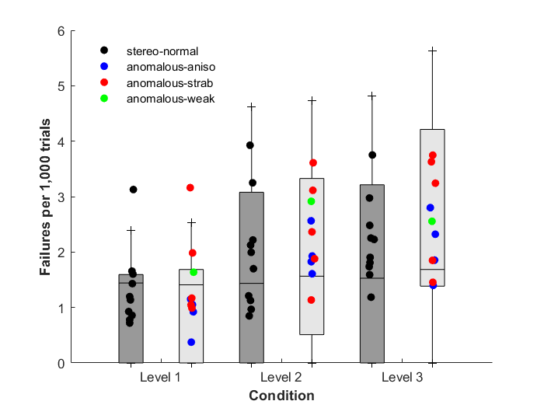The suppression task, inserted in the Halloween mechanics, proved to be valuable as a means of tracking participant engagement and suppression episodes. Figure 8 shows each participants’ failure to detect one of the dichoptic targets.

Figure 8. Box plots of Halloween game failures to detect dichoptic targets per 1,000 trials for stereo-normal (grey bars) and stereo-anomalous (white bars) groups for each condition (level 1, 2 and 3). Symbols represents data from one participant: stereo-normal (black), anisometropic (blue), strabismic (red) and stereo-weak (green). The horizontal line represents the group median while the whiskers represent the interquartile ranges.

A Kolmogorov-Smirnov test showed that the dichoptic errors did not follow a normal distribution when analyzed as a whole or when considering the six subgroup pairings between participant group (stereo-normal and stereo-anomalous) and cue scaffolding conditions (Level 1, 2, and 3) (*p* < 0.01 in all cases), thus a Kruskal-Wallis was applied. Kruskal-Wallis test showed significant differences as a function of condition level (*p* < 0.01) for both stereo-normal and stereo-anomalous group, except between level 2 and 3 in the stereo-anomalous group (*p* = 0.33). Mann-Whitney pairwise comparisons showed significant differences between the stereo-normal and stereo-anomalous group in dichoptic errors for all conditions when considered as a whole (*p* = 0.04) and in condition level 2 (*p* = 0.02), but not in condition level 1 (*p* = 0.58) or in condition level 3 (*p* = 0.11).

**Discussion**

Our aim was to evaluate whether cue scaffolding and dichoptic PL in VR could be used as a platform to train stereovision. To test our hypothesis, we designed two custom video games, which use a combination of demanding stereovision tasks. Our results show that most stereo-anomalous participants improved in the games and showed transfer to clinical and psychophysical tests of stereoacuity (Figure 3). Despite the different design and nature of the video games used in this study, these results support the viability of training stereoacuity by means of videogames, as other studies have previously stated (Ding & Levi, 2011; Levi et al., 2015; Vedamurthy et al., 2016; Xi et al., 2014).

It’s worth noting that the training activities are based on global stereopsis in both games, but the improvements are detected in both local and global stereoacuity clinical tests. Previous studies have demonstrated the opposite; an improvement from local to global stereopsis (Portela-Camino et al., 2018)

Our small sample size of participants with anisometropia or strabismus does not allow us to make statistical inferences beyond the stereo-normal and stereo-anomalous groups. Nevertheless, some participants did not show improvement across stereoacuity tests (AS1, AS2, AA3, and ASM1); all with strabismus except for AA3 who has anisometropia. It has been well documented in the literature that people with anisometropia retain better levels of stereoacuity at low frequencies (Levi et al., 2011). Although their stereoacuity is not as acute as normal, it is nevertheless functional. Thereby, people with anisometropia are more likely to recover stereoacuity after a PL treatment.

On the other hand, stereoacuity in people with strabismus is more impaired (Levi et al., 2015). A possible explanation for this difference is that suppression scotomas may be playing an active role in strabismus in order to avoid diplopia whereas in anisometropia it may be playing a more passive role as a result of degraded visual acuity.

Furthermore, people with strabismus have shown to be more resistant to stereoacuity training compared to people with anisometropia (Ding & Levi, 2011). Indeed, participants AMS1, AS1 and AS2 (all strabismic) showed no improvement when measured with Random Dot 3 but did show improvement when measured with the other stereoacuity tests. This may be due to poor performance on tests with random dot stimuli in people with any subtle binocular angle of deviation (Birch & Wang, 2009). Participant ASM1, with micro-strabismus, is likely to have developed a harmonious anomalous correspondence (Lang, 1983), which neural binocular connections are present but are not as acute as in normal correspondence. PL learning cannot go beyond that neural limitation, unless anomalous correspondence is treated before.

Regarding the stereo-normal group, most showed detectable improvements in the psychophysical stereoacuity tests. Those improvements were not detected by the clinical tests since all stereo-normal participants were at ceiling at the beginning of the study. However, previous studies have shown improvements in stereoacuity for individuals with normal binocular vision after training (Vedamurthy et al., 2016). Furthermore, in certain professions, where specific stereo demanding tasks are common such as those required from dressmakers, stereoacuity seems to be enhanced (Chopin et al., 2017). There is reasonable doubt about whether good stereoacuity is a requirement for becoming a dressmaker or whether stereoacuity is enhanced by the continuous stereo demanding tasks. However, our results indicate that training can improve stereoacuity in individuals normal binocular vision.

As for visual acuity, we did not find changes in visual acuity after training, which is not at all surprising. Previous studies aimed at improving stereoacuity have reported a lack of visual acuity change after training (Ding & Levi, 2011; Vedamurthy et al., 2016; Xi et al., 2014). [Infer about the nature of the stimulus/training and why no changes in VA make sense]. Furthermore, current state of the art of VR headsets lack fine resolution, which makes them a poo tool for visual acuity training.

For both clinical and psychophysical stereoacuity tests, stereo-normal participants with a worse initial stereo threshold show a higher PPR, meaning they improved more after training (Table 2). DartBoard in-game performance results show the same trend (Table 3). But the same is not reflected in the stereo-anomalous group with correlations indicating non-significance or even a negative correlation. According to the data presented here, initial stereoacuity threshold does not predict PPR in the stereo-anomalous group. A recent paper using a PL stereo training paradigm with random dot stimuli in participants with a history of amblyopia found strong inverse association between initial stereoacuity threshold and PPR (Portela-Camino et al., 2020). These trends have also been analyzed in studies with visual acuity recovery and concluded that baseline acuity loss does not predict PPR after dichoptic training (Mansouri et al., 2014).

For participants with strabismus, we did not detect a change in visual angle deviation. There is high scientific evidence of the success of training convergence insufficiency [ref7]. Despite each game requiring participants to diverge (DartBoard) or converge (Halloween) to moving targets, the small sample in our study was not sufficient to detect changes.

Although we did not measure binocular imbalance in this study, the Halloween game recorded when participants failed to detect dichoptic targets. Those failures tracked times at which participants were either suppressing or aware of the task. Stereo-normal participants are not supposed to have problems with suppression. However, they exhibit an increasing rate of failures across conditions, statistically significant, which may be attributed to boredom or fatigue. Stereo-anomalous behave statistically different than stereo-normal, with a higher error rate, i.e. the dichoptic errors are not only a measurement of fatigue but of something else, likely suppression. Nevertheless, it would be worth to embed a binocular imbalance test in a VR device. This would allow researchers the ability to track binocular vision beyond stereoacuity function. Anti-suppression therapy by means of dichoptic games has little or no effect on stereoacuity according to previous studies (Holmes et al., 2016; Kelly et al., 2018; Webber et al., 2016) whereas there are not studies yet, as far as we know, demonstrating whether direct stimulation of stereoacuity contributes to the re-balancing of vision. In fact, it has been suggested that improved stereoacuity after PL might reflect a decrease of interocular suppression (Xi et al., 2014), although it could also be the result of an enhancement of the signal in the amblyopic eye.

Although gamification can be a useful tool for increasing motivation, attention and compliance, it comes at a cost. In-game results are not as accurate in tracking the participants’ evolution compared to results obtained in a traditional PL task. Nevertheless, results obtained by the DartBoard game in this study, statistically demonstrate its coherence with clinical and psychophysical tests. First, in-game performance accuracy in condition level 3 correlates with clinical and psychophysical tests, in all three conditions (Table 7). Moreover, the correlation value obtained with Randot Circles is bigger than the correlation found between Randot Circles and any other clinical and psychophysical test used in this study. The explanation can be as easy as DartBoard game task (also Halloween) is more similar to a local stereoacuity test like Randot Circles than to any of the other tests. Second, in-game performance accuracy differentiates stereo-normal and stereo-anomalous participants across all three conditions. Third, improvement in condition level 3, where the only cue available is retinal parallax, is detected in almost all participants with the exception of two stereo-normal participants (PPR > 1).

Although those tendencies are coherent with the clinical and psychophysical tests, when we look at the in-game performance accuracy we realize that the DartBoard game provides a coarse value of stereoacuity (Table 1). The mean in-game performance accuracy for the stereo-normal group is 191 arc seconds (condition level 3), whereas it’s always below 30 arc seconds with any of the clinical and psychophysical tests used (Table 3). Nevertheless, the differences are lower in stereo-anomalous group with a mean value of 240 arc seconds in level 3. This seems reasonable when we compare with tests pre- and post- values.

The nature of the Halloween game does not provide a rich dataset. The disparities used in the game were much larger with the lowest stereoacuity demand set to 400”. In these conditions, it’s reasonable to suggest that perceptual training took place at threshold for most stereo-anomalous participants in DartBoard and slightly above threshold in Halloween, whereas clearly above threshold for stereo-normal participants. Nevertheless, stereo-normal participants also improved. When designing a PL task, above-threshold activities are not considered since there’s a notion that the activity would become (even) less interesting and engaging (Levi et al., 2015). Nevertheless, at least one study has reported improvements in stereoacuity in a control group whose activity was chosen to be above threshold [ref0]. In that case the improvement was attributed to the stimuli used (random dot), which potentially improves binocular fusion and noise to signal discrimination. Those aspect are especially important for strabismic patients. We cannot definitively know whether the improvement in clinical and psychophysical measures of stereoacuity were due to DartBoard and/or Halloween, but it’s important to point out that strabismic observers fare better with larger disparities (cite). Thus, the Halloween stimulus might have allowed them to strengthen their stereopsis by providing a stimulus they can latch on to. *Although the task used in our study is different, it is also true that our scheme takes advantage of virtual reality to improve binocular alignment.*

Finally, the novelty of this study is the use of a cue scaffolding as an approach for stereovision treatment. First, we demonstrated that cue scaffolding is present: in-game performance accuracy is statistically different for each condition regardless of group assignment (except level 2 and 3 for the stereo-normal group). Differences are more notable between condition 1 (almost all depth cues available) and condition 3 (only retinal disparity). At the beginning of the study, some participants exhibited better depth discrimination when all depth cues were present than when only retinal disparity was available, but others showed the opposite behavior (Figure 6) regardless of group.

Stereo-normal participants tendency, demonstrated statistically, is to improve more in the condition where they show initially lower skills. Nevertheless, stereo-anomalous group tendency is different. They improved more in the ability to integrate all depth cues than in stereoacuity considered as a single depth signal. Previous studies (Vedamurthy et al., 2016) have demonstrated that in adults deprived of normal binocular vision, repetitive depth demanding tasks contribute to a reweighting of depth cue integration where the weight of the disparity cue is increased (learned behavior). However, they do not achieve the same reweighting as normal control participants. In situations where disparity depth valuation is contradictory with other depth cues, as texture, the weight of disparity in the final estimation increases after treatment.

Our study unveils that sensory integration (condition level 1) is less reluctant to improvements than just disparity depth perception (condition level 3). This might explain the reports of patients regarding better depth perception after visual therapy treatments not correlated with measurable stereoacuity improvements (Tidbury et al., 2014).

**Conclusion**

An interventional model of direct stereopsis stimulation using VR program based on a row of three depth cue scaffolding conditions improved in-game performance in normal and stereo-deficient subjects. This improvement is transferred to stereoacuity measured with both clinical and psychometric stereoacuity test.

**REFERENCES**

Adams, W. J., Graf, E. W., & Anderson, M. (2019). Disruptive coloration and binocular disparity: Breaking camouflage. *Proceedings of the Royal Society B: Biological Sciences*, *286*(1896). https://doi.org/10.1098/rspb.2018.2045

Atkins, J. E., Fiser, J., & Jacobs, R. A. (2001). Experience-dependent visual cue integration based on consistencies between visual and haptic percepts. *Vision Research*, *41*(4), 449–461. https://doi.org/10.1016/S0042-6989(00)00254-6

Banks, M. S., Aslin, R. N., & Letson, R. D. (1975). Sensitive Period for the Development of Human Binocular Vision Author. In *New Series* (Vol. 190, Issue 4215).

Bergeron, B. (2005). *Developing serious games (Game development series)*. Charles River Media, Inc.

Birch, E. E. (2013). Amblyopia and binocular vision. *Progress in Retinal and Eye Research*, *33*(1), 67–84. https://doi.org/10.1016/j.preteyeres.2012.11.001

Birch, E. E., & Wang, J. (2009). Stereoacuity outcomes after treatment of infantile and accommodative esotropia. In *Optometry and Vision Science* (Vol. 86, Issue 6, pp. 647–652). https://doi.org/10.1097/OPX.0b013e3181a6168d

Chopin, A., Levi, D. M., & Bavelier, D. (2017). Dressmakers show enhanced stereoscopic vision. *Scientific Reports*, *7*(1). https://doi.org/10.1038/s41598-017-03425-1

Ding, J., & Levi, D. M. (2011). Recovery of stereopsis through perceptual learning in human adults with abnormal binocular vision. *Proceedings of the National Academy of Sciences*, *108*(37), E733–E741. https://doi.org/10.1073/pnas.1105183108

Ding, Jian, & Levi, D. M. (2011). Recovery of stereopsis through perceptual learning in human adults with abnormal binocular vision. *Proceedings of the National Academy of Sciences*, *108*(37), 733–741. https://doi.org/10.1073/pnas.1105183108

Ding, Jian, & Levi, D. M. (2014). Rebalancing binocular vision in amblyopia. *Ophthalmic and Physiological Optics*, *34*(2), 199–213. https://doi.org/10.1111/opo.12115

Ernst, M. O., & Banks, M. S. (2002). Humans integrate visual and haptic information in a statistically optimal fashion. *Nature*, *415*, 429–433. papers3://publication/uuid/F5A0DA65-72CA-4E88-A49C-2BDA6BF8E47F

Ernst, M. O., Banks, M. S., & Bülthoff, H. H. (2000). Touch can change visual slant perception. *Nature Neuroscience*, *3*(1), 19–21.

Gao, T. Y., Guo, C. X., Babu, R. J., Black, J. M., Bobier, W. R., Chakraborty, A., Dai, S., Hess, R. F., Jenkins, M., Jiang, Y., Kearns, L. S., Kowal, L., Lam, C. S. Y., Pang, P. C. K., Parag, V., Pieri, R., Raveendren, R. N., South, J., Staffieri, S. E., … Boswell, S. J. (2018). Effectiveness of a binocular video game vs placebo video game for improving visual functions in older children, teenagers, and adults with amblyopia: A randomized clinical trial. *JAMA Ophthalmology*, *136*(2), 172–181. https://doi.org/10.1001/jamaophthalmol.2017.6090

Giaschi, D., Lo, R., Narasimhan, S., Lyons, C., & Wilcox, L. M. (2013). Sparing of coarse stereopsis in stereodeficient children with a history of amblyopia. *Journal of Vision*, *13*(10), 1–15. https://doi.org/10.1167/13.10.17

Gibson, E. J. (1963). Perceptual learning. *Annual Review of Psychology*, *14*(1), 29–56.

Held, R., Birch, E., & Gwiazda, J. (1980). Stereoacuity of human infants. *Proceedings of the National Academy of Sciences*, *77*(9), 5572–5574.

Hess, R. F., Mansouri, B., & Thompson, B. (2010). A new binocular approach to the treatment of Amblyopia in adults well beyond the critical period of visual development. *Restorative Neurology and Neuroscience*, *28*(6), 793–802. https://doi.org/10.3233/RNN-2010-0550

Hess, Robert F, Thompson, B., & Baker, D. H. (2014). Binocular vision in amblyopia: Structure, suppression and plasticity. *Ophthalmic and Physiological Optics*, *34*(2), 146–162. https://doi.org/10.1111/opo.12123

Hillis, J. M., Watt, S. J., Landy, M. S., & Banks, M. S. (2004). Slant from texture and disparity cues: Optimal cue combination. *Journal of Vision*, *4*(12), 967–992. https://doi.org/10.1167/4.12.1

Holmes, J. M., & Clarke, M. P. (2006). Amblyopia. *Lancet*, *367*, 1343–1351.

Holmes, J. M., Manh, V. M., Lazar, E. L., Beck, R. W., Birch, E. E., Kraker, R. T., Crouch, E. R., Erzurum, S. A., Khuddus, N., Summers, A. I., & Wallace, D. K. (2016). Effect of a binocular ipad game vs part-time patching in children aged 5 to 12 years with amblyopia a randomized clinical trial. *JAMA Ophthalmology*, *134*(12), 1391–1400. https://doi.org/10.1001/jamaophthalmol.2016.4262

Jacobs, R. A., & Fine, I. (1999). Experience-dependent integration of texture and motion cues to depth. *Vision Research*, *39*(24), 4062–4075. https://doi.org/10.1016/S0042-6989(99)00120-0

Kapp, K. M. (2012). *The gaminification of learning and instruction: Game-based methods and strategies for training and education* (1st ed.). Pfeiffer & Company.

Kelly, K. R., Jost, R. M., Dao, L., Beauchamp, C. L., Leffler, J. N., & Birch, E. E. (2016). Binocular ipad game vs patching for treatment of amblyopia in children a randomized clinical trial. *JAMA Ophthalmology*, *134*(12), 1402–1408. https://doi.org/10.1001/jamaophthalmol.2016.4224

Kelly, K. R., Jost, R. M., Wang, Y. Z., Dao, L., Beauchamp, C. L., Leffler, J. N., & Birch, E. E. (2018). Improved binocular outcomes following binocular treatment for childhood amblyopia. *Investigative Ophthalmology and Visual Science*, *59*(3), 1221–1228. https://doi.org/10.1167/iovs.17-23235

Knill, D. C. (2007a). Learning Bayesian priors for depth perception. *Journal of Vision*, *7*(8), 1–20. https://doi.org/10.1167/7.8.13

Knill, D. C. (2007b). Robust cue integration: A Bayesian model and evidence from cue-conflict studies with stereoscopic and figure cues to slant. *Journal of Vision*, *7*(7), 1–24. https://doi.org/10.1167/7.7.5

Knill, D. C., & Saunders, J. A. (2003). Do humans optimally integrate stereo and texture information for judgments of surface slant? *Vision Research*, *43*(24), 2539–2558. https://doi.org/10.1016/S0042-6989(03)00458-9

Lang, J. (1983). Microtropia. *International Ophthalmology*, *6*(1), 33–36. https://doi.org/10.1007/bf00137371

Levi, D. M., Knill, D. C., & Bavelier, D. (2015). Stereopsis and amblyopia: A mini-review. *Vision Research*, *114*(2015), 17–30. https://doi.org/10.1016/j.visres.2015.01.002

Levi, D. M., & Li, R. W. (2009). Perceptual learning as a potential treatment for amblyopia: A mini-review. *Vision Research*, *49*(21), 2535–2549. https://doi.org/10.1016/j.visres.2009.02.010

Levi, D. M., McKee, S. P., & Movshon, J. A. (2011). Visual deficits in anisometropia. *Vision Research*, *51*(1), 48–57. https://doi.org/10.1016/j.visres.2010.09.029

Li, J., Spiegel, D. P., Hess, R. F., Chen, Z., Chan, L. Y. L., Deng, D., Yu, M., & Thompson, B. (2015). Dichoptic training improves contrast sensitivity in adults with amblyopia. *Vision Research*, *114*, 161–172. https://doi.org/10.1016/j.visres.2015.01.017

Li, R., Polat, U., Makous, W., & Bavelier, D. (2009). Enhancing the contrast sensitivity function through action video game training. *Nature Neuroscience*, *12*(5), 549–551. https://doi.org/10.1038/nn.2296

Li, R. W., Ngo, C., Nguyen, J., & Levi, D. M. (2011). Video-game play induces plasticity in the visual system of adults with amblyopia. *PLoS Biology*, *9*(8). https://doi.org/10.1371/journal.pbio.1001135

Li, X., Dumoulin, S. O., Mansouri, B., & Hess, R. F. (2007). The fidelity of the cortical retinotopic map in human amblyopia. *European Journal of Neuroscience*, *25*, 1265–1277. https://doi.org/10.1111/j.1460-9568.2007.05356.x

Love, G. D., Hoffman, D. M., Hands, P. J. W., Gao, J., Kirby, A. K., Banks, M. S., Matsuki, . M, Kani, H., Tatsugami, F., Yoshikawa, S., Narabayashi, I., Lee, S.-W., Shinohara, H., & Nomura, E. (2009). *High-speed switchable lens enables the development of a volumetric stereoscopic display References and links*. www.displaytech.com

MacMillan, N. A., & Creelman, C. D. (2005). *Detection theory: A user’s guide* (2nd ed.). Taylor & Francis.

Manh, V. M., Holmes, J. M., Lazar, E. L., Kraker, R. T., Wallace, D. K., Kulp, M. T., Galvin, J. A., Shah, B. K., & Davis, P. L. (2018). A Randomized Trial of a Binocular iPad Game Versus Part-Time Patching in Children Aged 13 to 16 Years With Amblyopia. *American Journal of Ophthalmology*, *186*, 104–115. https://doi.org/10.1016/j.ajo.2017.11.017

Mansouri, B., Singh, P., Globa, A., & Pearson, P. (2014). Binocular training reduces amblyopic visual acuity impairment. *Strabismus*, *22*(1), 1–6. https://doi.org/10.3109/09273972.2013.877945

Mckee, S. P., & Taylor, D. G. (2010). The precision of binocular and monocular depth judgments in natural settings. *Journal of Vision*, *10*, 1–13. https://doi.org/10.1167/10.10.5.Introduction

Melmoth, D. R., Finlay, A. L., Morgan, M. J., & Grant, S. (2009). Grasping deficits and adaptations in adults with stereo vision losses. *Investigative Ophthalmology and Visual Science*, *50*(8), 3711–3720. https://doi.org/10.1167/iovs.08-3229

Melmoth, D. R., & Grant, S. (2006). Advantages of binocular vision for the control of reaching and grasping. *Experimental Brain Research*, *171*, 371–388. https://doi.org/10.1007/s00221-005-0273-x

Michael, D. R., & Chen, S. L. (2005). *Serious games: Games that educate, train, and inform*. Muska & Lipman/ Premier-Trade.

Portela-Camino, J. A., Martín-González, S., Ruiz-Alcocer, J., Illarramendi-Mendicute, I., & Garrido-Mercado, R. (2018). A Random Dot Computer Video Game Improves Stereopsis. *Optometry and Vision Science*, *95*(6), 523–535. https://doi.org/10.1097/OPX.0000000000001222

Portela-Camino, J. A., Martín-González, S., Ruiz-Alcocer, J., Illarramendi-Mendicute, I., Piñeiro-Llorens, D., & Garrido-Mercado, R. (2020). Predictive factors for the perceptual learning in stereodeficient subjects (Accepted for publication). *Journal of Optometry*.

Schoemann, M. D., Lochmann, M., Paulus, J., & Michelson, G. (2017). Repetitive dynamic stereo test improved processing time in young athletes. *Restorative Neurology and Neuroscience*, *35*(4), 413–421. https://doi.org/10.3233/RNN-170729

Tavers, T. A. (1938). Suppression of vision in squint and its association with retinal correspondence and amblyopia. *The British Journal of Ophthalmology*, 577–604.

Tidbury, L. P., Black, R. H., & O’Connor, A. R. (2014). Perceiving 3D in the absence of measurable stereo-acuity. *Br Ir Orthopt*, *11*, 34–38.

van Beers, R. J., van Mierlo, C. M., Smeets, J. B. J., & Brenner, E. (2011). Reweighting visual cues by touch. *Journal of Vision*, *11*(10), 1–16. https://doi.org/10.1167/11.10.1

Vedamurthy, I., Knill, D. C., Huang, S. J., Yung, A., Ding, J., Kwon, O.-S., Bavelier, D., & Levi, D. M. (2016). Recovering stereo vision by squashing virtual bugs in a virtual reality environment. *Philosophical Transactions of the Royal Society B: Biological Sciences*, *371*(1697), 20150264. https://doi.org/10.1098/rstb.2015.0264

Vedamurthy, I., Nahum, M., Bavelier, D., & Levi, D. M. (2015). Mechanisms of recovery of visual function in adult amblyopia through a tailored action video game. *Scientific Reports*, *5*, 1–7. https://doi.org/10.1038/srep08482

Vedamurthy, I., Nahum, M., Huang, S. J., Zheng, F., Bayliss, J., Bavelier, D., & Levi, D. M. (2015). A dichoptic custom-made action video game as a treatment for adult amblyopia. *Vision Research*, *114*(2015), 173–187. https://doi.org/10.1016/j.visres.2015.04.008

Wade, N., & Swanston, M. (2013). *Visual Perception* (3rd ed.). Psychology Press. https://doi.org/10.4324/9780203082263

Wallace, D. K., Lazar, E. L., Melia, M., Birch, E. E., Holmes, J. M., Hopkins, K. B., Kraker, R. T., Kulp, M. T., & Pang, Y. (2011). Stereoacuity in children with anisometropic amblyopia. *Journal of AAPOS*, *15*(5), 455–461. https://doi.org/10.1016/j.jaapos.2011.06.007

Webber, A. L., & Wood, J. (2005). Amblyopia: prevalence, natural history, functional effects and treatment. *Cinical and Experimental Optometry*, *88*(6), 365–375.

Webber, A. L., Wood, J. M., & Thompson, B. (2016). Fine motor skills of children with amblyopia improve following binocular treatment. *Investigative Ophthalmology and Visual Science*, *57*(11), 4713–4720. https://doi.org/10.1167/iovs.16-19797

Wheatstone, C. (1838). Contributions to the physiology of vision.-Part the first. On some remarkable, and hitherto unobserved, phenomena of binocular vision. *Philosophical Transactions of the Royal Society of London*, *128*, 371–394. https://www.jstor.org/stable/108203

Xi, J., Jia, W. L., Feng, L. X., Lu, Z. L., & Huang, C. B. (2014). Perceptual learning improves stereoacuity in amblyopia. *Investigative Ophthalmology and Visual Science*, *55*(4), 2384–2391. https://doi.org/10.1167/iovs.13-12627